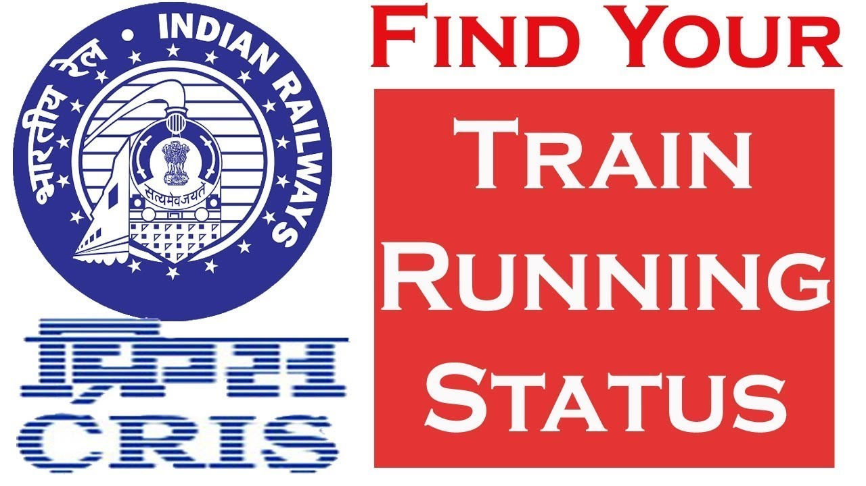

Internship Report
Centre for Railway Information Systems (CRIS)
Internship Title: Data Science and Machine Learning Intern
Internship Period: 14th May, 2025- 29th May,2025
Project Title: SD Limit Value Prediction for Track Geometry Monitoring

Abstract
This internship report provides a comprehensive account of the work undertaken and knowledge acquired during my tenure as a Data Science and Machine Learning Intern at the Centre for Railway Information Systems (CRIS)—the dedicated IT arm of Indian Railways. CRIS plays a pivotal role in building and maintaining the technological infrastructure that supports India’s vast and dynamic railway network.
During the internship, I had the opportunity to work on a critical project titled “SD Limit Value Prediction”, which addressed the operational challenge of identifying when a track section is likely to breach safety thresholds based on the degradation of track geometry parameters, particularly the UN1L standard deviation—a key indicator of vertical track unevenness. These SD parameters are derived from regular inspection data collected by track recording cars, and they play a central role in ensuring safe and efficient railway operations.
The core objective of the project was to use historical inspection data to forecast the time-to-limit breach for each section of railway track. This would allow for predictive maintenance instead of relying solely on reactive interventions. By applying machine learning techniques, I aimed to model the progression of track degradation and estimate future standard deviation values with sufficient accuracy to inform maintenance planning.
Throughout the internship, I was involved in the entire data science workflow, including data sourcing, cleaning, feature engineering, model selection, hyperparameter tuning, and evaluation. Special attention was paid to integrating static threshold limit files with dynamic measurement data—requiring careful mapping based on domain-specific logic such as section speed. I trained and evaluated multiple models, with the Random Forest Regressor showing the best balance between interpretability and predictive performance.
The project also tackled real-world challenges such as data quality issues, missing or corrupted inspection records, and non-uniform intervals between inspections, which complicated traditional time-series modeling. As a result, I devised an approach to estimate SD growth rate per section and used it to calculate the expected number of days before the safety limits would be breached.
The internship not only deepened my technical proficiency in machine learning and data analytics but also provided exposure to critical aspects of safety in railway operations, regulatory compliance, and data-driven decision-making in a government-led infrastructure setting. This report outlines the background of the problem, the data sources used, the modeling methodology, implementation pipeline, challenges faced, and the results achieved. Ultimately, it demonstrates how machine learning can be leveraged in the public sector to enhance infrastructure safety, optimize maintenance, and reduce operational risks.

Introduction

1.1 Background
- Indian Railways operates one of the largest rail networks in the world. Ensuring the safety and efficiency of such a vast system necessitates regular inspection and predictive maintenance of railway tracks. Track Geometry Monitoring is performed periodically to record key parameters that describe the condition of railway tracks. Among these, standard deviation values (SDs) of different geometry parameters such as alignment and level are critical indicators.
1.2 Track Geometry Defects
- Track defects are primarily identified by monitoring deviations in geometry parameters like:
- UN1L: Longitudinal Level (Left Rail)
- UN2: Cross Level or alignment
- Gauge, Twist, and Warp
- These parameters are recorded regularly via measurement cars. Abnormal values may lead to unsafe train operations, derailments, or excessive wear. SD values indicate the consistency of track quality over a segment.
1.3 Motivation
- Traditionally, track inspections provide a reactive approach—detecting defects after they occur. However, with access to historical inspection data, it becomes feasible to forecast future degradation. This shift to predictive maintenance using data science not only improves safety but also reduces operational costs and unplanned downtimes.
1.4 Objective
- The main objective of this project was to:
- Build a machine learning model to predict the UN1L SD values for each track segment.
- Estimate when a segment’s SD value would breach its limit, as specified by safety standards.
- Enable data-driven decision making for maintenance scheduling in Indian Railways.
1.5 Problem Statement
Indian Railways routinely inspects its track infrastructure to monitor and maintain safety standards. A key parameter recorded during these inspections is the Standard Deviation of the Longitudinal Level (UN1L), which reflects vertical irregularities along the railway track. Over time, these deviations tend to grow due to usage, wear, and environmental factors.
For safety compliance, threshold values (called SD limits) are defined for different speed categories of railway sections. If the UN1L value for a track section exceeds its corresponding limit, it indicates a potential safety risk and triggers the need for maintenance or corrective actions.
Currently, maintenance decisions are reactive—taken only after the UN1L exceeds the limit. This reactive approach delays interventions and increases the risk of service disruptions or accidents.
The key problem is:
"Can we predict, in advance, when the UN1L value for a track section will exceed its SD limit, using past inspection data?"
This would allow railway authorities to schedule proactive maintenance, thereby improving safety and reducing operational downtime.
1.6 Solution

The solution involved developing a machine learning model to predict the future values of the track parameter UN1L (Standard Deviation of Longitudinal Level) and estimate when it would breach its defined safety limit based on historical inspection data. A Random Forest Regressor was trained using cleaned and merged datasets containing inspection records and corresponding SD limit values mapped through section speeds. By analyzing the rate at which UN1L values increased over time, the model could forecast the likely date of limit breach for each track section. This allowed for proactive maintenance planning by providing advance warnings of potential track degradation, thereby improving safety and reducing unplanned disruptions.

Project 1: SD Limit Value Prediction

Objective :

The objective of the SD Limit Prediction project was to build a machine learning model to predict when the SD value (specifically UN1L) of a track section would exceed a predefined threshold (as per safety regulations). The prediction would assist in proactive maintenance scheduling and infrastructure health monitoring.

Methodology:
- Data Sources and Preparation

- Main Dataset: Consisted of inspection data such as RUNDATE, SECTION_SPEED, UN1L, RUNNO, etc.

- SD Limits File: A static file containing SD limit values mapped to section speed ranges (FROMSPEED to TOSPEED) with fields like UN2, AL2.

- Data Cleaning & Feature Engineering

- Removed rows with missing SECTION_SPEED or UN1L values.
- Converted date formats and dropped irrelevant columns (SECCODE, LINECODE, etc.).
- Merged the SD limit values into the main dataset based on the SECTION_SPEED of each row.

- Model Building

3.1 GMT Computation
Geometric Mean Trend (GMT) is often used in rail monitoring to track degradation over time. While our approach focused more on linear and average growth trends of the UN1L values, future enhancement can include computing GMTs for more robust predictive analytics.
3.2 Model Selection
Several regression models were considered for predicting the progression of UN1L values over time. After preliminary experimentation with linear regression, decision trees, and ensemble models, the Random Forest Regressor was selected for its superior ability to handle non-linear trends, robustness to outliers, and interpretability via feature importance scores. Random Forest is especially useful for structured tabular datasets with complex interdependencies between features.
3.3 Model Details
- Model Used: Random Forest Regressor
- Hyperparameters: 200 estimators, max depth = 10, random state fixed for reproducibility
- Feature Set:
Included numerical features such as SECTION_SPEED, RUNNO, and merged limit values (AL2, UN2), which capture both track conditions and corresponding safety thresholds.
- Target Variable: UN1L (Standard Deviation of Longitudinal Level)
- Train-Test Split: 80% for training, 20% for testing using train_test_split()

- Model Implementation & Results
4.1Data Preprocessing
- Null Handling: Dropped records with critical missing values (UN1L, SECTION_SPEED)
- Date Parsing: Converted RUNDATE into proper datetime format for trend analysis
- Column Reduction: Dropped non-informative fields like SECCODE, LINECODE
- Limit Merging:
Used custom logic to match the SECTION_SPEED with the appropriate limit values (UN2, AL2) from the static SD limits file. This mapping was not a direct join but depended on whether SECTION_SPEED fell between FROMSPEED and TOSPEED — handled using a row-wise mapping function.
4.2 Features Used
Final model training was restricted to numerical features only, as categorical variables like region or zone were either missing, inconsistent, or added noise without improving performance. Feature importance analysis showed that SECTION_SPEED, RUNNO, and corresponding limits had the highest predictive power.
4.3 Track Degradation Model
- Assumption: UN1L grows approximately linearly over time between inspection runs
- Computation:
For each section, the average growth rate of UN1L per day was computed using differences between consecutive runs:
Avg Growth=UN1Llater−UN1LearlierDays Between Runs\text{Avg Growth} = \frac{\text{UN1L}_{\text{later}} - \text{UN1L}_{\text{earlier}}}{\text{Days Between Runs}} Avg Growth=Days Between RunsUN1Llater​−UN1Learlier​​
- Prediction:
Using the model’s predicted UN1L value and this average growth rate, we estimated the number of days remaining until the AL2 (alert limit) would be breached. The projected date was computed by adding this number of days to the last known inspection date (RUNDATE).

- Evaluation Metrics
- Root Mean Squared Error (RMSE)
- MAE
- R² Score
- RMSE to Mean Ratio
6.Time-to-limit Estimation
- Predicted SD growth rate per day using past inspection data.
- Used this rate to forecast the date on which SD values would likely cross limits.
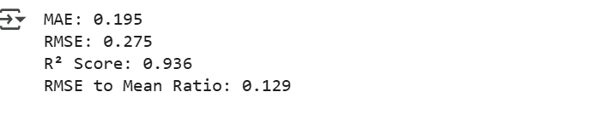
7.Observation


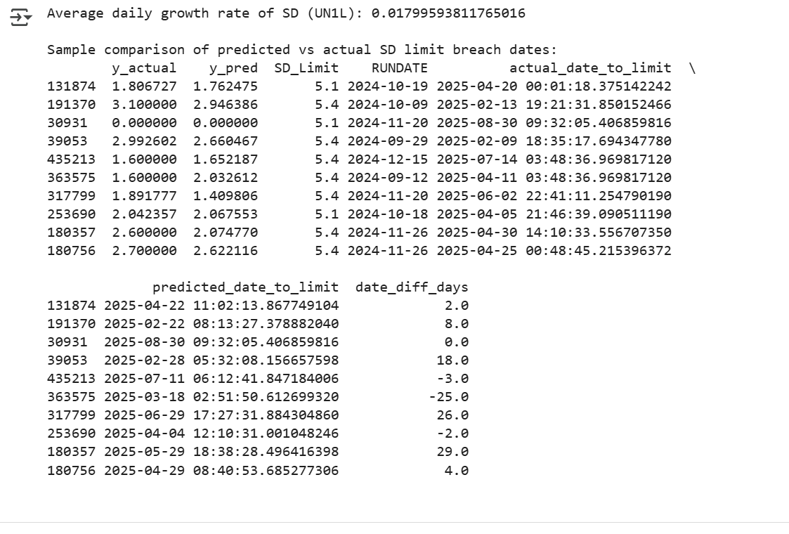
7.1Limit Breach Estimation:

- The average daily increase in SD (UN1L) allowed the model to reasonably estimate when a section might cross its safety limit.
- Visualization of actual vs predicted values showed tight correlation, validating the model's generalization ability.

8.Challenges and Outcomes
- Challenge: Parsing inconsistent date formats
Outcome:
Fixed using pd.to_datetime() with error coercion and standard format assumptions

- Challenge: Joining limit values based on speed range
Outcome:
Applied row-wise function to match SECTION_SPEED with correct SD limit range

- Challenge: Handling missing or corrupted data
Outcome: Applied numerical filtering and removed problematic entries
- Challenge: Predicting time to SD Breach
Outcome:
Estimated average SD growth rate per day and projected days to breach using simple arithmetic models

- Challenge: Low signal from categorical variables
Outcome: Final model was restricted to numerical columns only for stability and accuracy

9.
Conclusion
The internship at CRIS provided invaluable hands-on experience in the application of data science techniques to railway safety monitoring. The SD Limit Prediction project sharpened my understanding of time-series modeling, real-world constraints like fixed threshold limits, and model evaluation in operational settings.
I also learned about the intricacies of data merging, cleaning, model performance tuning, and practical deployment considerations for a safety-critical domain. This experience has significantly contributed to my technical and analytical skill development and prepared me for future challenges in data science applications across industries.

